**Evolution 2**

Six different forms of isolation commonly cause a new species to form:

1. Geographic isolation

2. Polyploidy

3. Habitat isolation

4. Behavioral isolation

5. Temporal isolation

6. Reproductive isolation

------------------------------------------------------------------------------------

**Geographic Isolation**

Geographic isolation occurs when species are separated. Mountain ranges, canyons, rivers, lakes, or glaciers may cause significant isolation between species.

**Polyploidy**

Polyploidy is a type of mutation that results from errors during meiosis. Instead of being haploid (n) or diploid (2n), polyploid organisms can be tetraploid (4n) or octoploid (8n). Nearly half of all flowering plants and the vast majority of ferns are polyploid. Polyploid organisms cannot breed with organisms that are not polyploid and therefore are isolated from them.

**DR SALMA KHALED BIOLOGY EDUCATOR**

**Habitat isolation**

Same area, but different habitats (e.g., water vs. land snakes).

**Behavioral isolation**

Different mating behaviors or signals prevent reproduction (e.g., Male firefly).

**Temporal isolation**

Different breeding or flowering times.

**Reproductive Isolation**

Closely related species may be unable to mate because of anatomical incompatibility. For example, a small male dog and a large female dog cannot mate because of the enormous size differences between the two animals.

**DR SALMA KHALED BIOLOGY EDUCATOR**

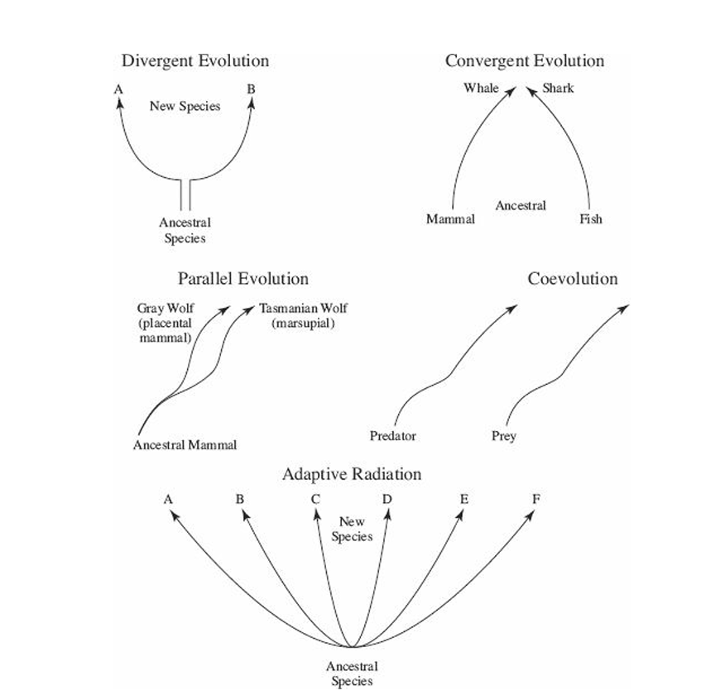

**DR SALMA KHALED BIOLOGY EDUCATOR**

**PATTERNS OF EVOLUTION**

**Divergent Evolution** – When a population becomes isolated, it faces new selective pressures and evolves into a new species. Homologous structures show this pattern.

**Convergent Evolution** – Unrelated species in similar environments develop similar adaptations. Example: whales (mammals) and fish both have streamlined bodies, but different ancestry. Analogous structures are evidence.

**Parallel Evolution** – Two related species evolve similar traits after diverging from a common ancestor, often due to similar environments (e.g., gray wolf and Tasmanian wolf).

**Coevolution** – Two interacting species influence each other’s evolution. Example: bees and flowers adapt to enhance pollination.

**Adaptive Radiation** – A single species evolves into many forms to occupy different ecological niches, as with Darwin’s finches developing varied beaks for different diets.

**DR SALMA KHALED BIOLOGY EDUCATOR**

**Theories About Evolution**

**Gradualism** – Proposes that species evolve from a common ancestor slowly over long periods through many small changes, with fossils showing every stage. Rejected because the fossil record rarely shows transitional forms.

**Punctuated Equilibrium** – Proposed by Stephen J. Gould and Niles Eldredge; suggests species remain unchanged for long periods, then new species appear suddenly, often replacing the ancestral form.

**HOW LIFE BEGAN**

The early Earth’s atmosphere likely contained methane (CH₄), ammonia (NH₃), water vapor (H₂O), and nitrogen (N₂), but no free oxygen.

* **Oparin & Haldane (1920s):** Proposed that without oxygen, organic molecules could form and persist.
* **Miller & Urey (1950s):** Simulated early Earth using electricity and UV light, producing organic molecules like amino acids.
* **Sidney Fox:** Produced proteinoid microspheres—membrane-bound, cell-like structures that lasted for hours in the lab.

**The Heterotroph Hypothesis and the Theory of Endosymbiosis**

The heterotroph hypothesis suggests the first cells were anaerobic, heterotrophic prokaryotes that absorbed organic molecules from the primordial soup, appearing about 3.5 billion years ago.  
About 1.5 billion years ago, eukaryotic cells evolved when small bacteria lived inside larger prokaryotes in a mutually beneficial relationship, giving rise to nuclei, chloroplasts, and mitochondria.

**DR SALMA KHALED BIOLOGY EDUCATOR**

**IMPORTANT CONCEPTS OF EVOLUTION**

1. Evolution is not always slow — bacteria can develop antibiotic resistance in months.
2. It does not occur at the same rate in all organisms — humans have changed greatly in 100,000 years, while the horseshoe crab has hardly changed.
3. It does not always make organisms more complex — the sea star embryo is complex (bilateral symmetry) but the adult is simpler (radial symmetry).
4. Evolution occurs in populations, not individuals — short-necked giraffes died out, leaving long-necked ones.
5. Evolution is directed by environmental changes — ocean animals must be streamlined to move freely.

**DR SALMA KHALED BIOLOGY EDUCATOR**